EU CATCH system: Six months in, how is it really working?
oliver7520
Aug 4
3 min read
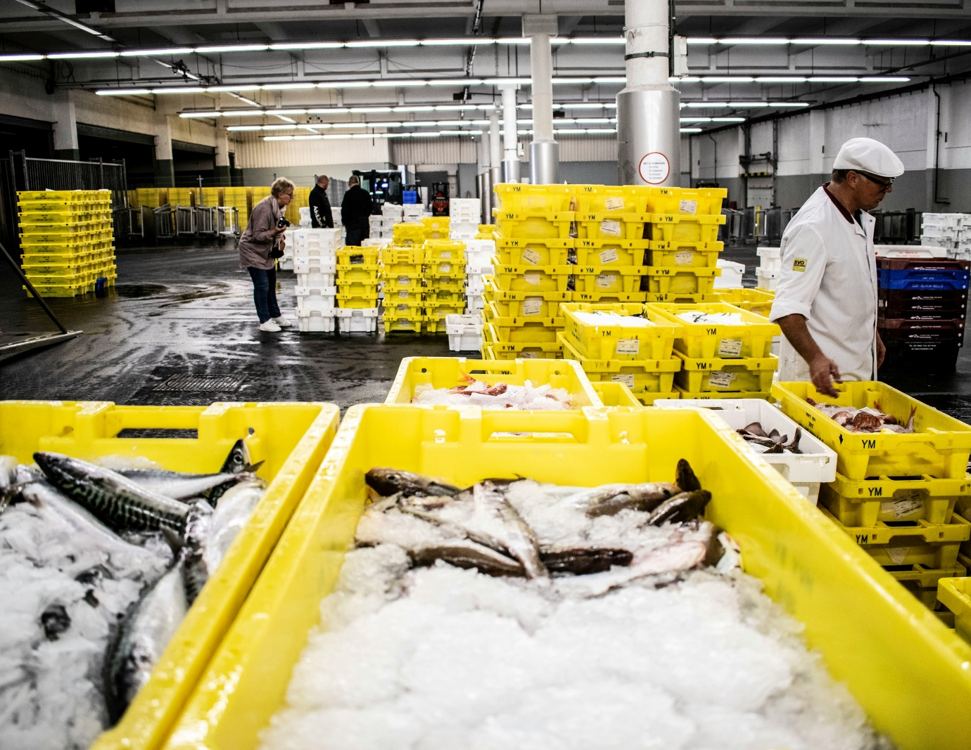
The EU’s CATCH system went live on 10 January 2026 as the new digital backbone for wild-caught fishery product imports. It requires digital catch certificates, importer declarations and full traceability in TRACES NT, with the stated aim of closing loopholes in the old paper-based regime and making it harder for IUU (illegal, unreported and unregulated) fish to enter the EU market. From day one, the system has been mandatory for EU importers, and the original six-month grace period for certain new data fields ran until 10 July 2026. Since that date, a fully completed CATCH entry has been required for new certificates, with only limited, country-specific flexibilities remaining (notably for the US until November 2026).

On paper, the timeline looks clear: the transitional window is over, the rules are in force, and CATCH is now the standard. But the reality on the ground has been more complicated. Within the first two weeks of launch, industry bodies such as Seafood Europe logged dozens of operational challenges, and six months in, many importers, processors still describe the system as unworkable in practice for parts of their business.

The positives are real: CATCH is a single EU-wide platform that should, in theory, make data more transparent, reduce document fraud and allow authorities to cross-check catches more effectively. For well-resourced operators with relatively simple supply chains, the shift to digital certificates has already improved visibility and control. However, the drawbacks have been significant. The system has been criticised for:

Lack of integration with national customs control systems, leading to stock being refused or delayed at major ports.

Technical gaps and errors: server timeouts, slow performance on multi-vessel consignments (sometimes minutes per refresh), and search functions that fail to locate certificates while simultaneously flagging them as duplicates.

Data entry burdens: many third-country authorities still issue paper certificates, so EU importers must manually re-type large volumes of data. File-size limits (initially 2 MB) have been too small for lengthy certificates, and key data fields do not always flow automatically between steps (e.g. from certificate to processing statement to importer declaration), forcing re-entry of the same information.

Operational mismatches: requirements such as recording zero-kg catches and very tight tolerance margins are seen as unrealistic for certain fisheries, increasing the risk of unintentional non-compliance and fines.

Structural issues: the system does not yet fully cover some important categories (e.g. certain indirect imports, re-exports of processed products, or all species), and the absence of a formal delegation mechanism means agents often perform compliance-critical tasks without clear legal authority, creating liability uncertainty and additional workload.

These issues have translated into real trade disruption: containers held at ports, extra costs for agents and intermediaries, and delays that are particularly damaging for fresh and chilled seafood. The EU has responded with targeted extensions (for example, prolonging US flexibilities to 30 November 2026), but industry groups argue that the problems are systemic rather than cosmetic, and that full, smooth implementation will take longer than the original timetable allowed.

It’s also important to remember that the transitional architecture is not yet complete. The current rules allow old catch certificates issued before 10 January 2026 to remain in use in CATCH until 10 January 2028, and simplified catch certificates validated before 10 January 2027 will be valid for one year. Only from 10 January 2028 will the revised templates (normal catch certificate, simplified catch certificate and Annex IV processing statement) become mandatory for all countries, with no exceptions. In other words, the full CATCH framework is still rolling out, and the next 18 months will be critical for both businesses and authorities.

At Customs Wise, we specialise in complex food customs, and supporting fish importers is a core part of our work. We are already supporting several fish importers in preparing and processing CATCH declarations through TRACES NT, aligning them with CHEDs and customs entries, and managing the practical issues that arise at the BCP. If you are importing wild-caught fishery products into the EU or Ireland and need help navigating CATCH, grace periods and the wider IUU requirements, get in touch,
we can help you keep your shipments moving while staying compliant.

